关键词：

vitamin C Powder

1．Basic Information：

Product Name | vitamin C
Specification | 99%
Appearance | White crystal powder
Mesh | 80 mesh
Molecular formula | C6H8O6
Molecular weight | 176.12
CAS No | 50-81-7
Flow Chart | /
Solubility | Soluble the water

- Introduction of vitamin C:
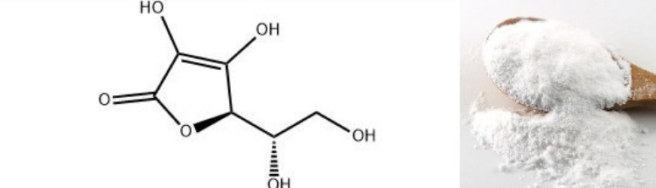
Vitamin C, also known as ascorbic acid and L-ascorbic acid, is a vitamin found in food and used as a dietary supplement. The disease scurvy is prevented and treated with vitamin C-containing foods or dietary supplements. Evidence does not support use in the general population for the prevention of the common cold.There is, however, some evidence that regular use may shorten the length of colds.It is unclear if supplementation affects the risk of cancer, cardiovascular disease, or dementia.It may be taken by mouth or by injection.

3．Why we need supply vitamin C?
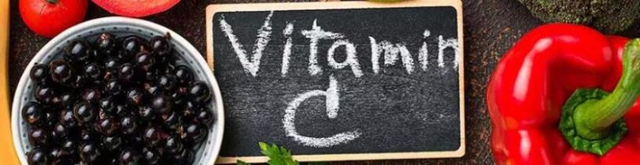

3.1.Keep food, fruits and beverage fresh and prevent them from producing unpleasant smell.
3.2.Prevent formation of nitrous amine from nitrous acid in meat products.
3.3.Improve dough quality and make baked food expand to its maximum.
3.4.Compensate the Vitamin C losses of beverage ,fruits and vegetables during processing rocedures.
3.5.Used as nutritional element in additives,Feed additives.

4. The role of vitamin C in the skin care products:

4.1 offers anti-oxidant abilityand brightens skin one.

4.2 Removes melanin and rejuvenates skin.

4.3 Makes skin smoother and more delicate.
- Application:

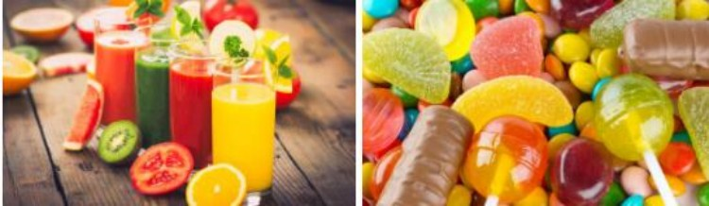

Food additives,cosmetic ingredients and health care supplement.
6.COA：
Certificate of Analysis
Product Name | L-ascorbic acid (vitamin C)
Batch Number | VC2001025
Manufacture Date | 2022-01-05
Report Date | 2022-01-06
Expiry Date | 2024-01-04
Quantity | 5000KG
Country of origin | China

Item of Analysis | Specification | Results
Appearance | White or yellowish crystalline powder | Qualified
Identification | Positive reaction | Qualified
Assay(C₆H₈O₆) | ≥99.0% | 99.6%
Specific optical rotation | +20.5 °~+21.5 ° | +20.9 °
Residue on ignition | ≤0.1% | Conform
Heavy metal(As Pb) | ≤10.0mg/kg | Conform
Arsenic(As) | ≤3.0mg/kg | Conform
Lead(Pb) | ≤2.0mg/kg | Conform
Iron(Fe) | ≤2.0mg/kg | Conform
Copper(Cu) | ≤5.0mg/kg | Conform
Conclusion | Conform to the standard GB14754-2010

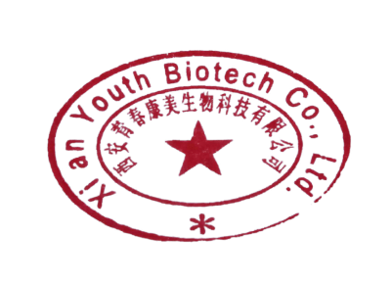
Shelf Life : 24 months under the conditions below, no antioxidant used
Package : 25 kg/carton outside and double food plastic bags inside

QC : Guo Shan QA: Feng Li

